Annonymous Function Programs…

# Program 1: Print odd numbers in an array…

**let** odd=**function**(value){

for (**let** i=0;i<value.length;i++){

        if(value[i]%2!=0){

                console.log(value[i])

        }

}

}

odd([11,22,33,44,55])

# Result:

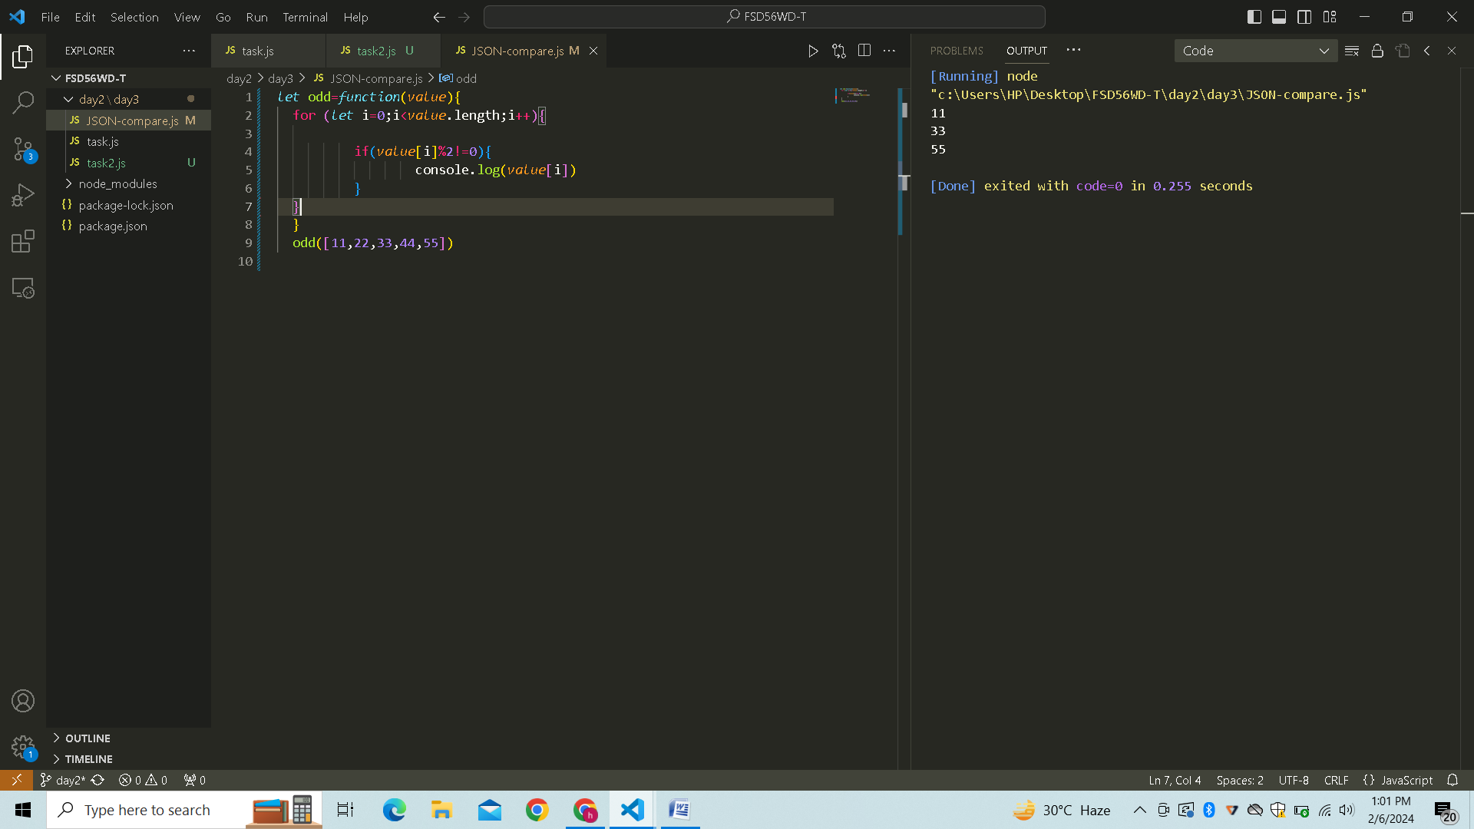

# Program 2: Sum of all numbers in an array…

**let** odd=**function**(value){

**let** sum =0;

        for (**let** i=0;i<value.length;i++){

               sum=sum+value[i]

        }

        console.log(sum)

        }

        odd([11,22,33,44,55])

# Result:

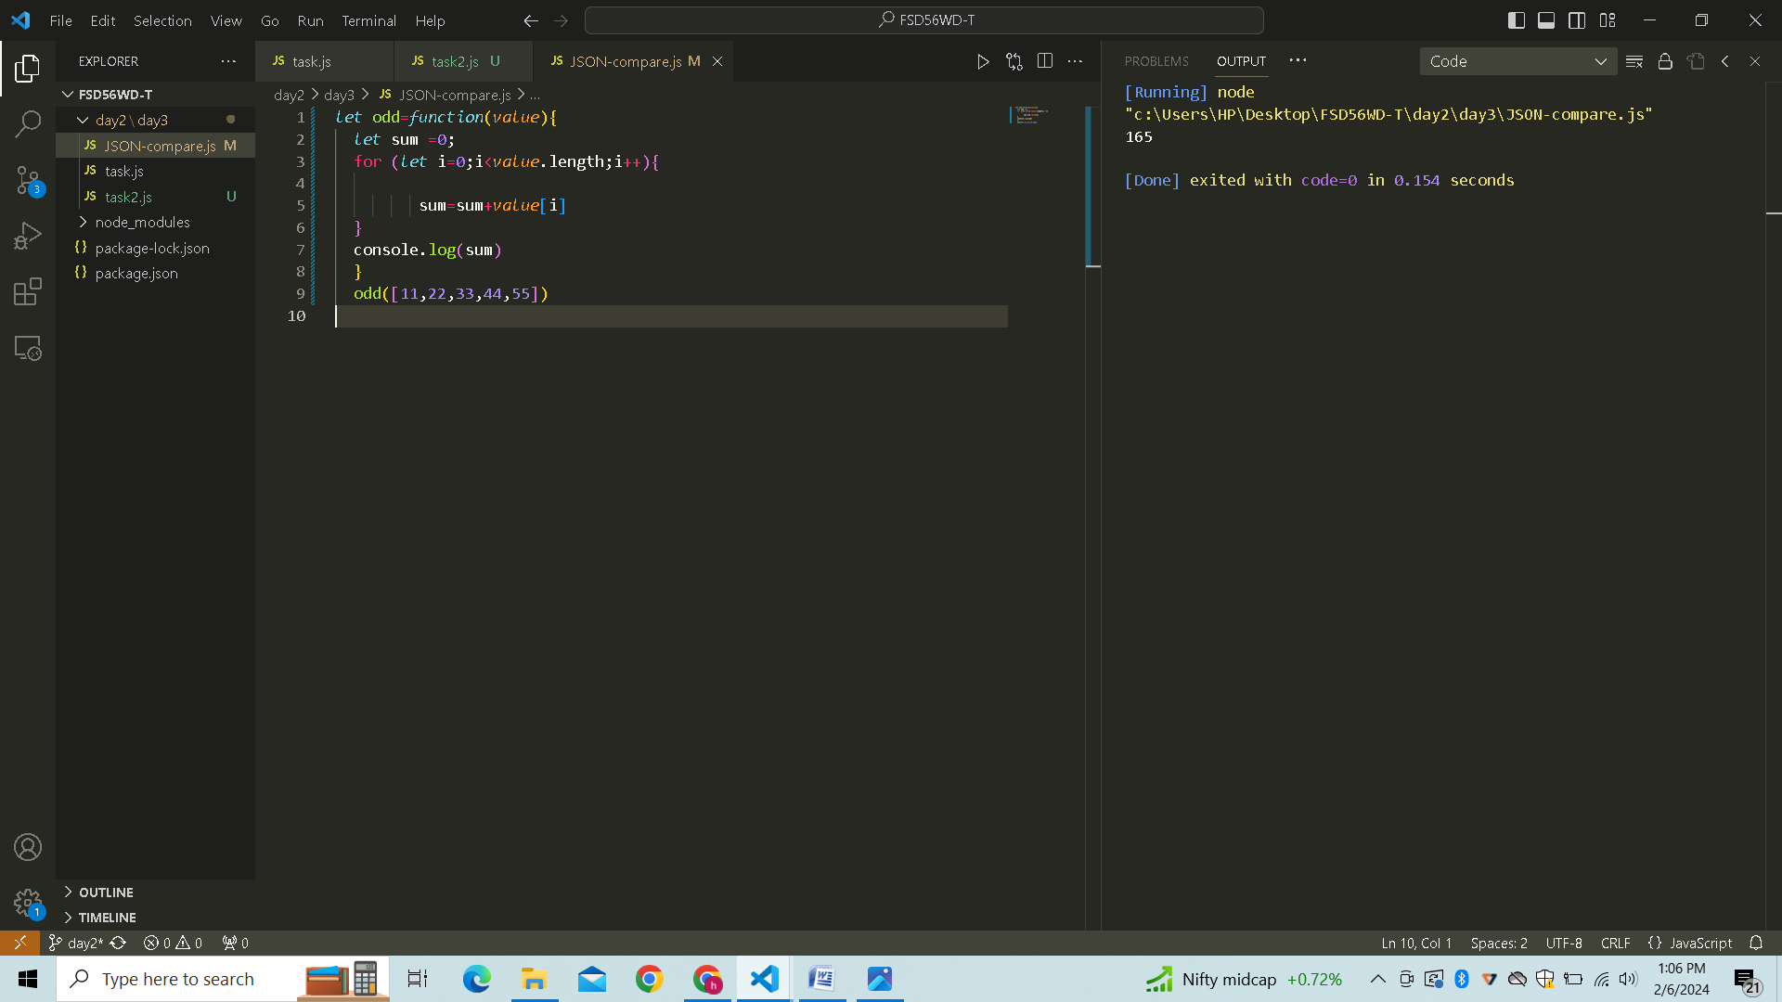

# Program 3: Convert all the strings to title caps in a string array…

*let* titleCaps =*function*(*str*) {

*str* = *str*.toLowerCase().split(' ');

    for (*let* i = 0; i < *str*.length; i++) {

*str*[i] = *str*[i].charAt(0).toUpperCase() + *str*[i].slice(1);

    }

    return *str*.join(' ');

}

console.log(titleCaps("my name is harish"));

# Result:

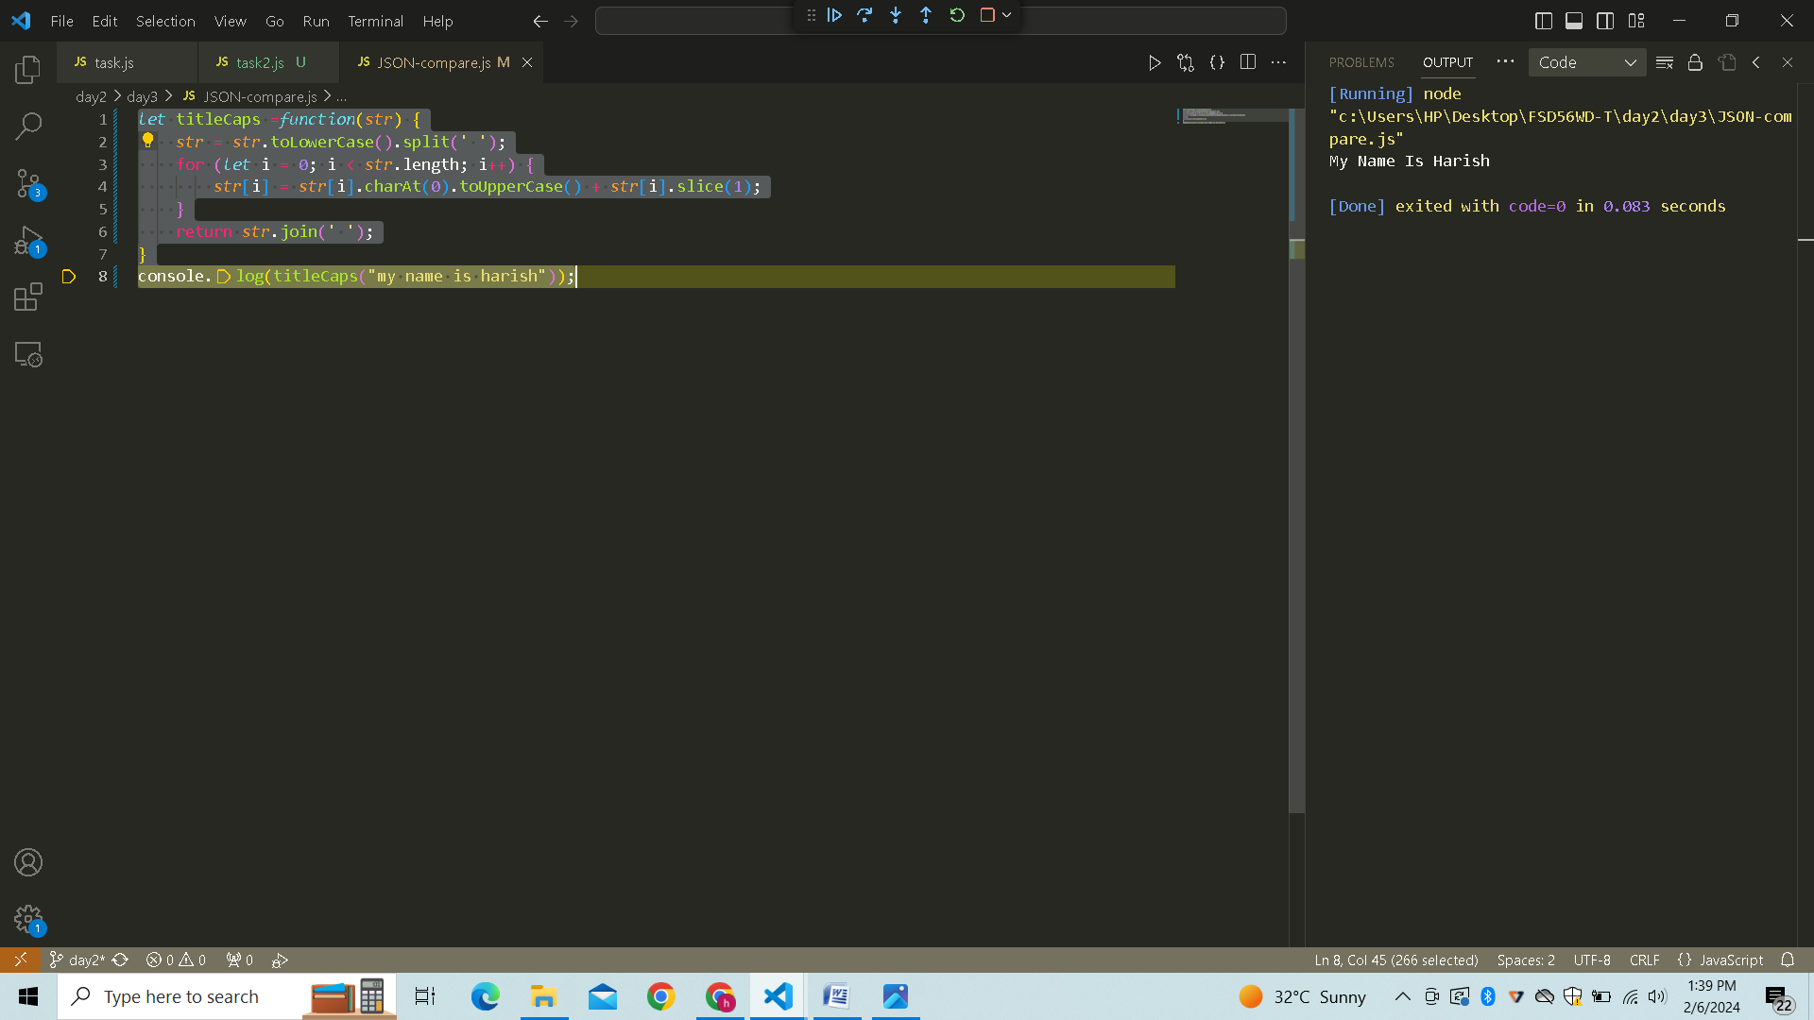

# Program 4: Return all the prime numbers in an array…

*let* prime =*function*(*numArray*){

*numArray*=*numArray*.filter((*number*) *=>*{

        for (*let* i=2 ; i <=Math.sqrt(*number*); i++){

            if (*number* % i==0)

            return false;

        }

        return true;

    });

    console.log(*numArray*)

}

prime([1,2,3,4,5,6,7,8,9,10]);

# Result:

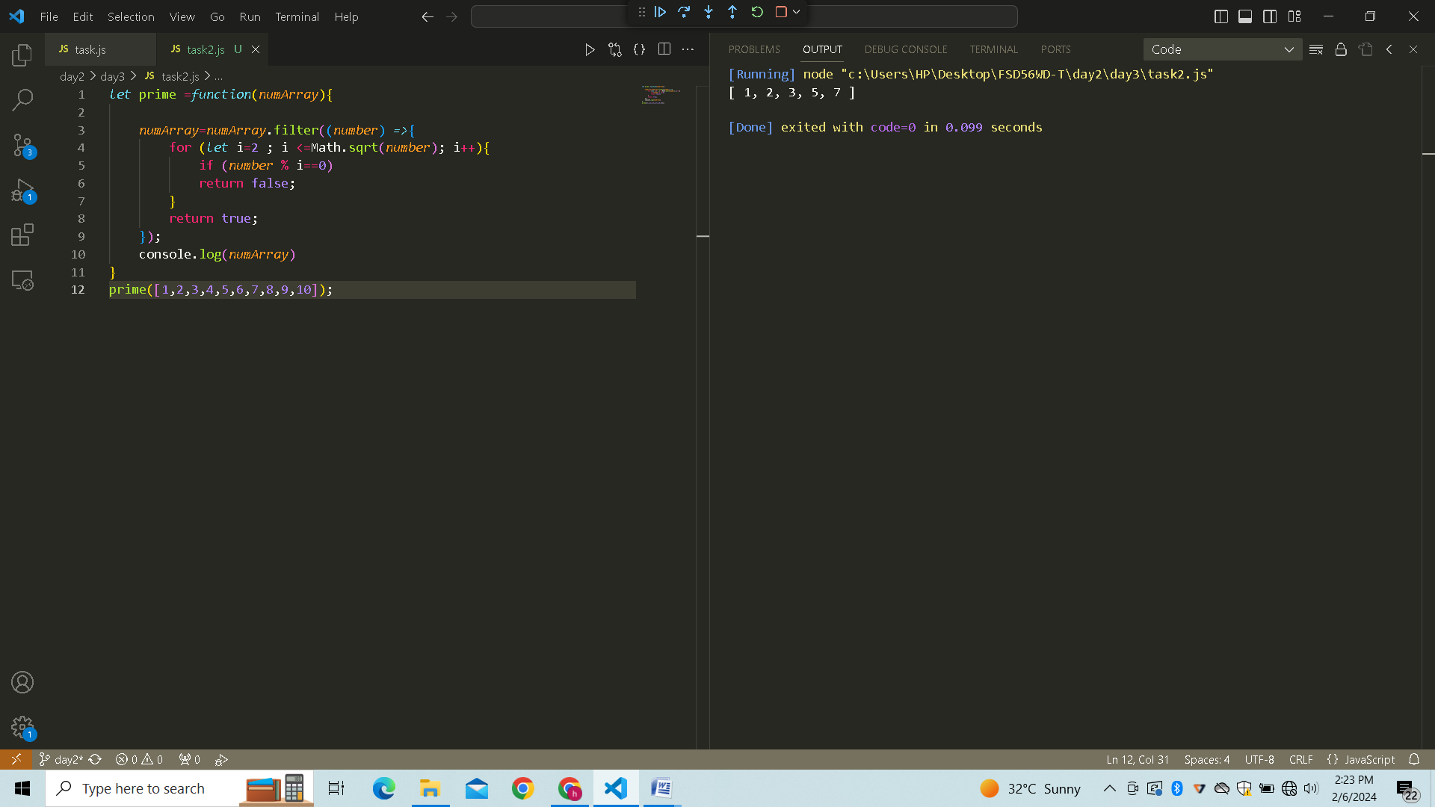

# Program 5: Remove the duplicate numbers in an array…

*let* duplicate = *function*(*array*){

*let* dup=[... new *Set*(*array*)];

    console.log(dup)

}

duplicate([1,1,2,3,3,4,4,5,6])

# Result :

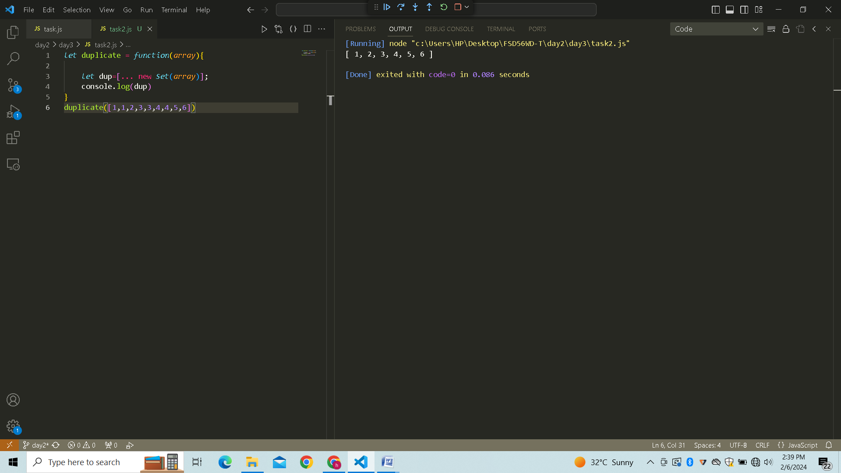

# Program 6: Rotate the array by n times…

*let* rotate = *function* (*nums*, *k*) {

    for (*let* i = 0; i < *k*; i++) {

*nums*.unshift(*nums*.pop());

    }

    console.log(*nums*);

}

rotate([1, 2, 3, 4, 5], 2);

# Result:

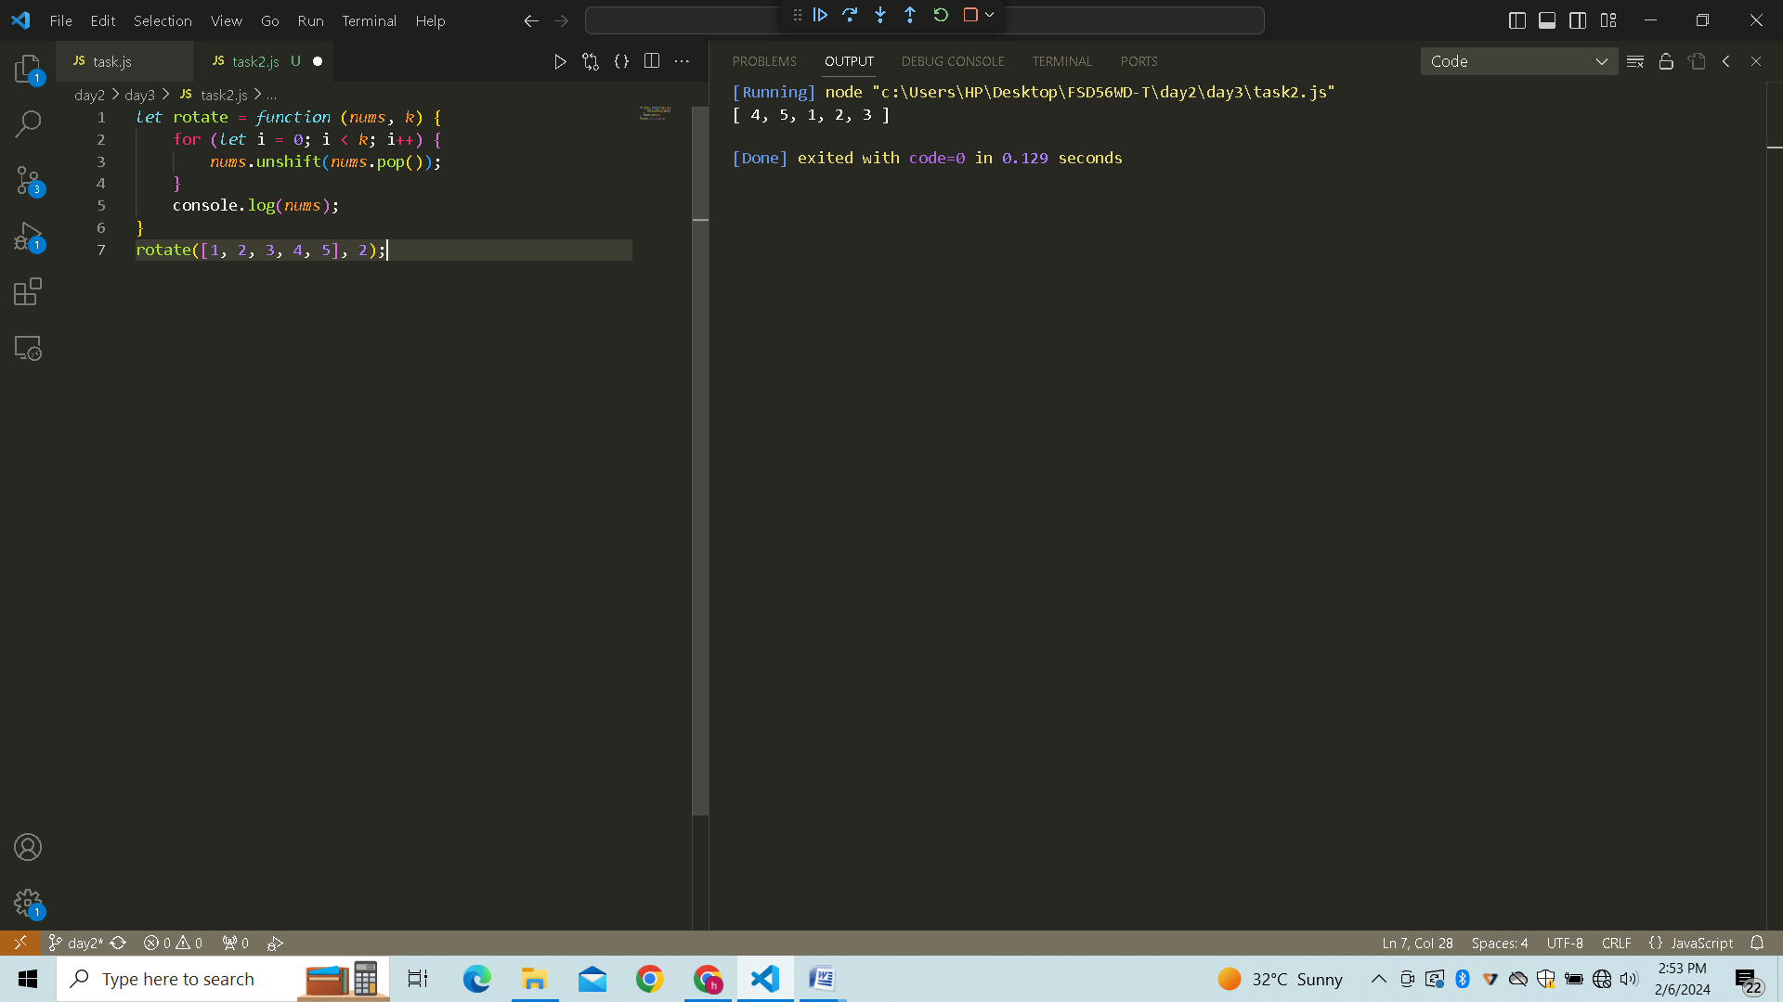

# Program 7:Return all the pallindromes in an array…

*let*  isPalindrome= *function*(*word*){

*let* rev =*word*.split('').reverse().join('');

    return *word* == rev;

}

*let* words=['abc','mom',"picture",'dad']

for (word of words){

    if(isPalindrome(word)){

        console.log(word);

    }

}

# Result:

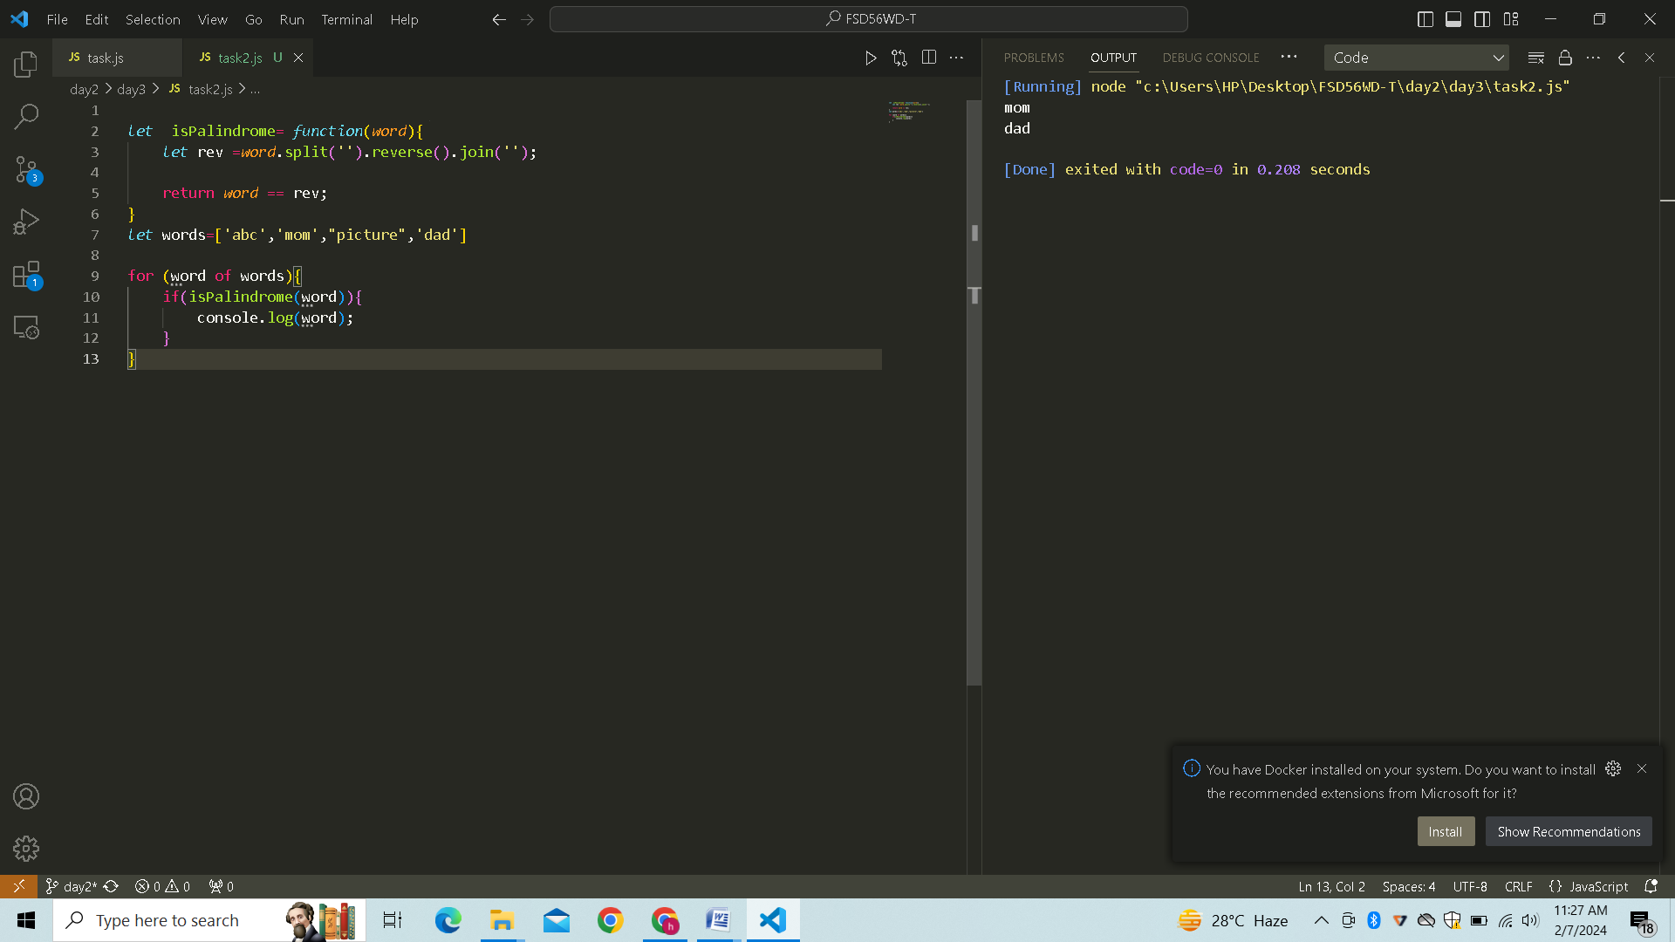

# Program 8: Return median of two sorted arrays of the same size…

*let* median = *function*(*arr1*,*arr2*){

*let* sortedArray = *arr1*.concat(*arr2*);

sortedArray.sort((*a*,*b*)*=>a*-*b*)

console.log(sortedArray);

*let* midNum =sortedArray.length/2;

*let* num1 = sortedArray[midNum-1]

*let* num2 = sortedArray[midNum]

console.log(((num1+num2)/2).toFixed(1));

}

median(([1,3,5,7,9]),([2,4,6,8,10]))

# Result :

